**IT214** Lab Report **LAB-1**

Date-August 26,2022

Name-Divya Kirtikumar Patel

Student ID-202001420

**Lab Group- 6 Section - 8**

**Query 1: Show all the details of the ticket collector.**

SQL Query –

SELECT * FROM rail_db.ticketcollector;

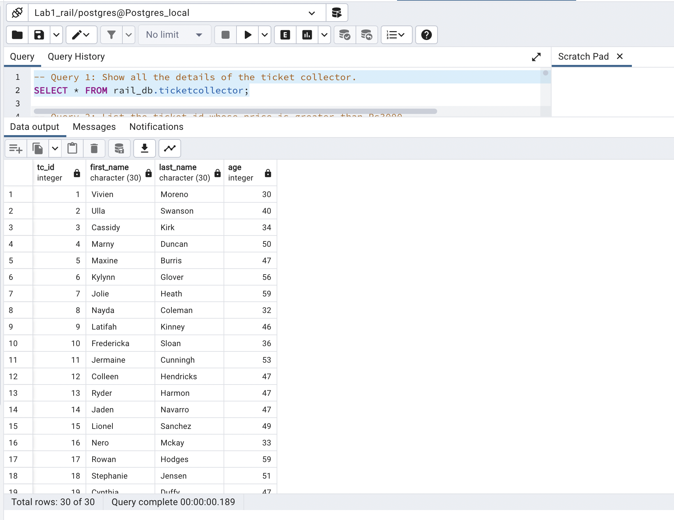

No of rows = 30

**Query 2: List the ticket id whose price is greater than Rs3000.**

SQL Query -

SELECT ticket_id FROM rail_db.ticket

WHERE Amount >3000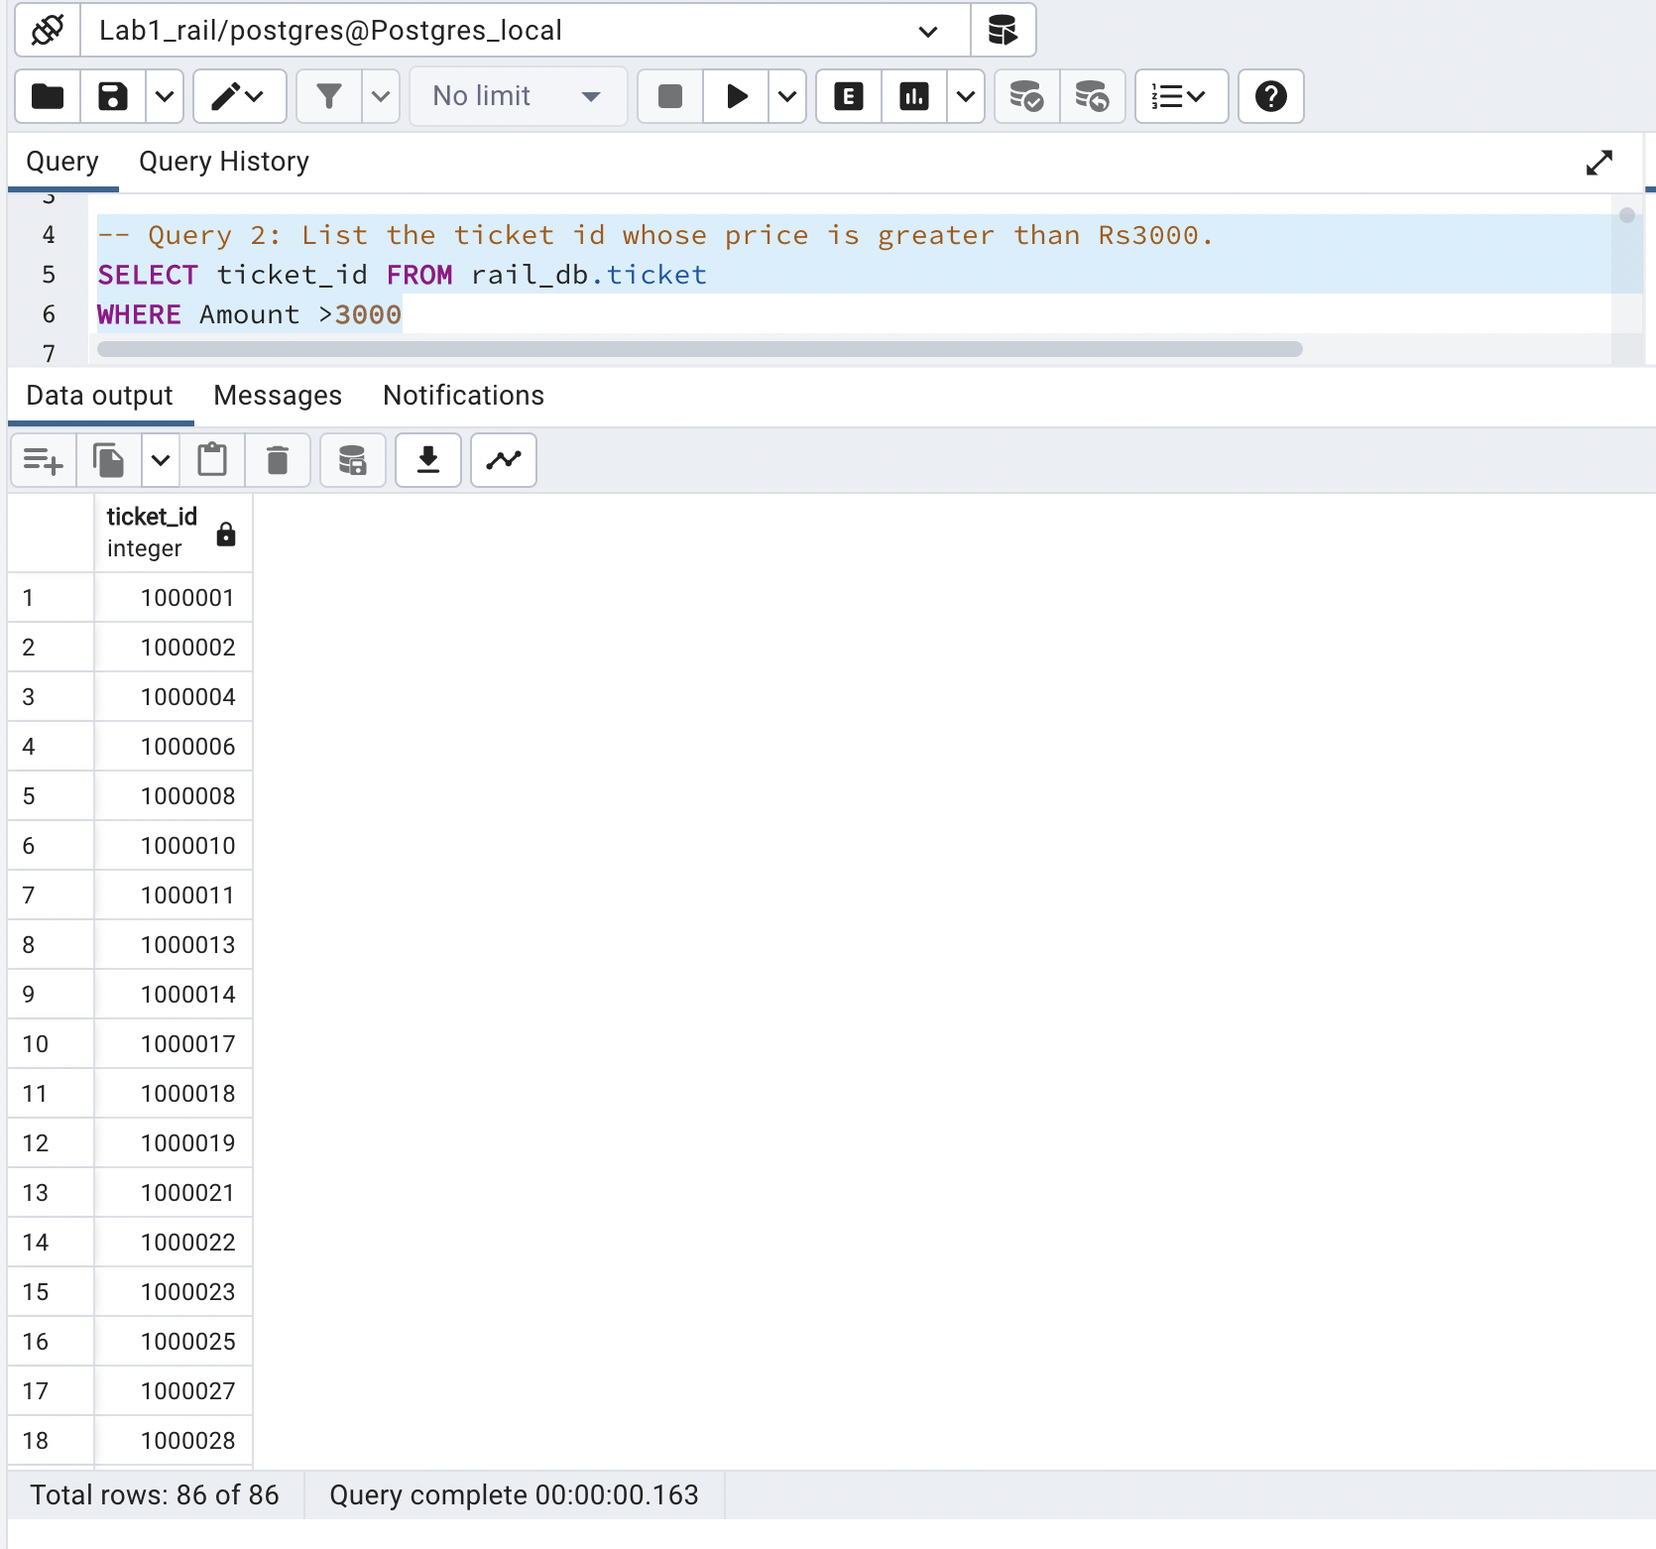

No of rows = 86

**Query 3: Show all the food items that are not available.**

**Ans. :** SELECT item FROM rail_db.pantry

where availability = 'No';

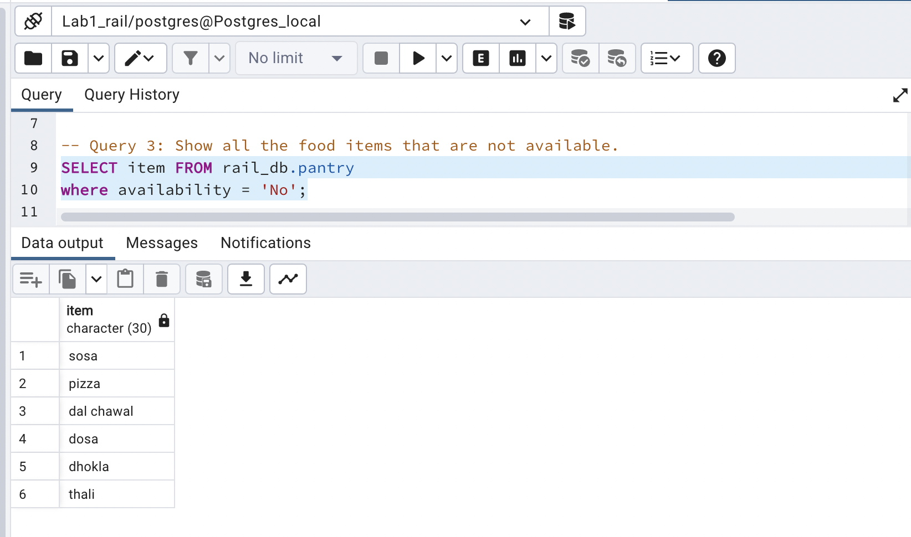

No of rows = 6

**Query 4: Count the number of female passengers.**

**Ans. :** SELECT count(gender) FROM rail_db.passengerdetails

WHERE gender = 'female';

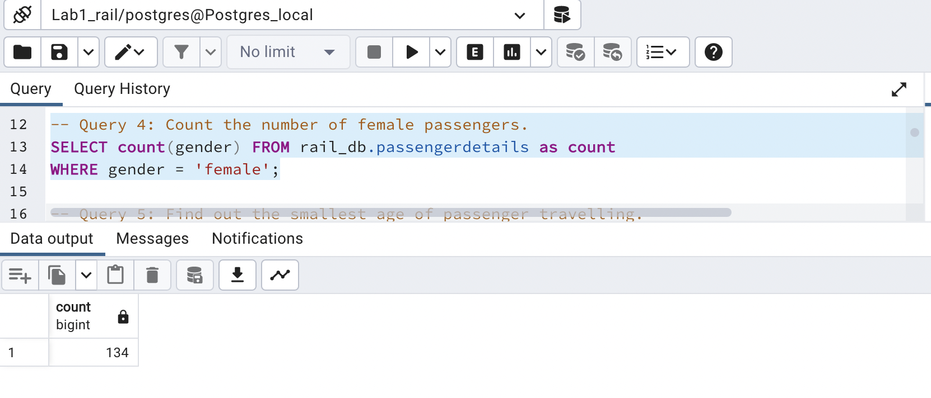

No of rows = 1

**Query 5: Find out the smallest age of passenger travelling.**

**Ans. :** SELECT MIN(age) as minimum FROM rail_db.passengerdetails;

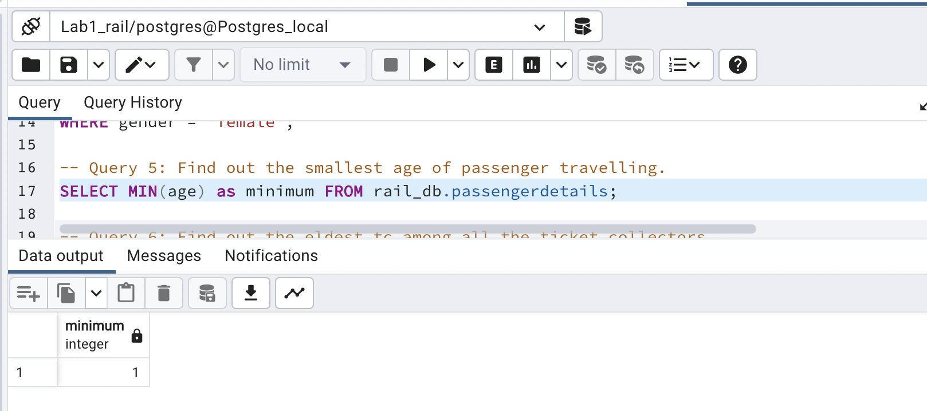

No of rows = 1

**Query 6: Find out the eldest tc among all the ticket collectors.**

**Ans. :**

SELECT max(age) as eldest FROM rail_db.ticketcollector;

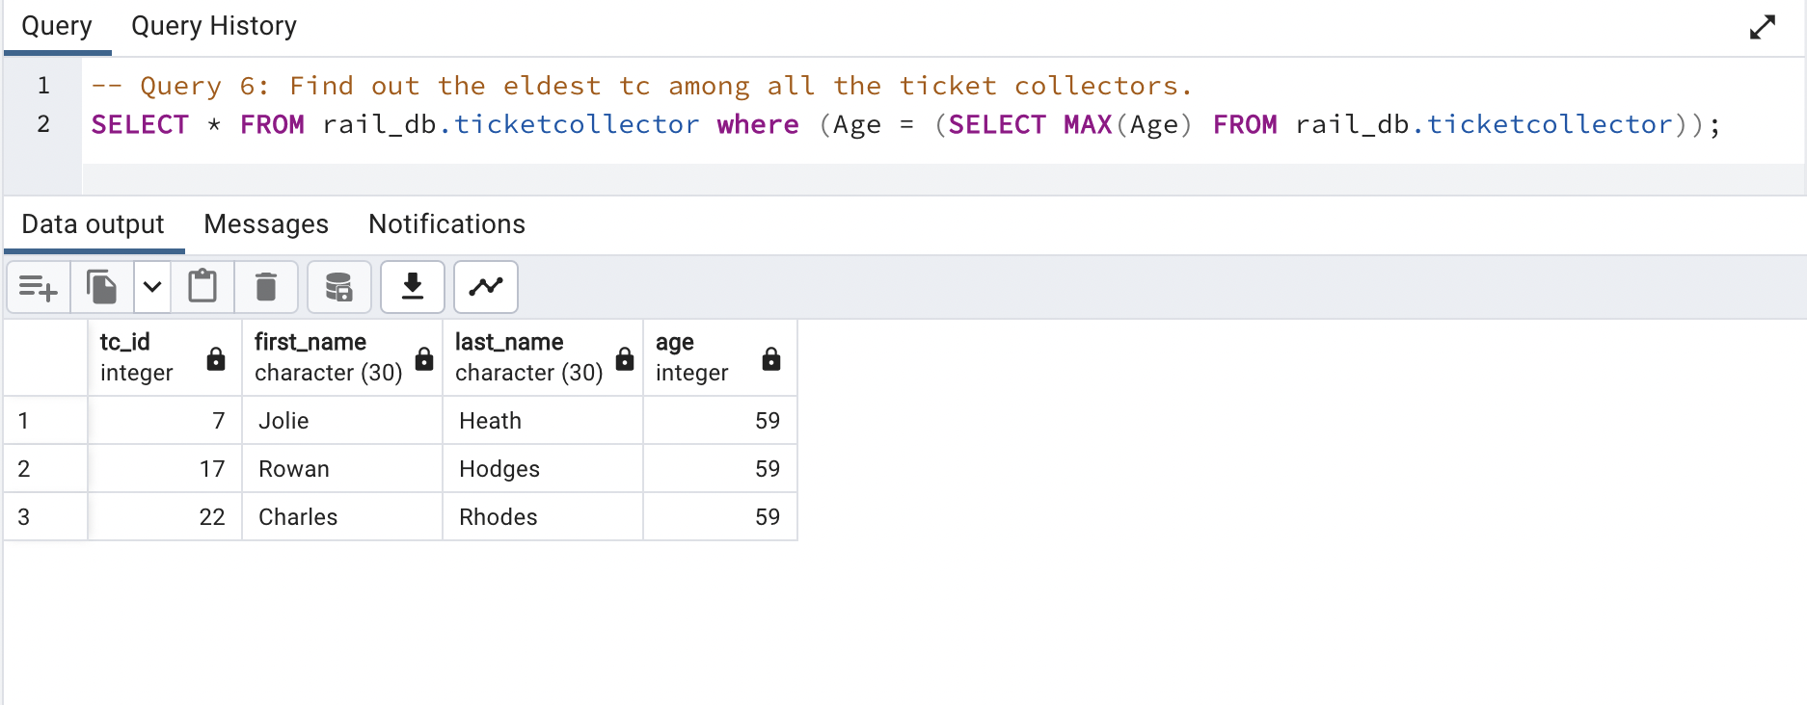

No of rows = 3

**Query 7: Write a query to print all the food items being served on the train.**

**Ans. :** SELECT DISTINCT item from rail_db.pantry;

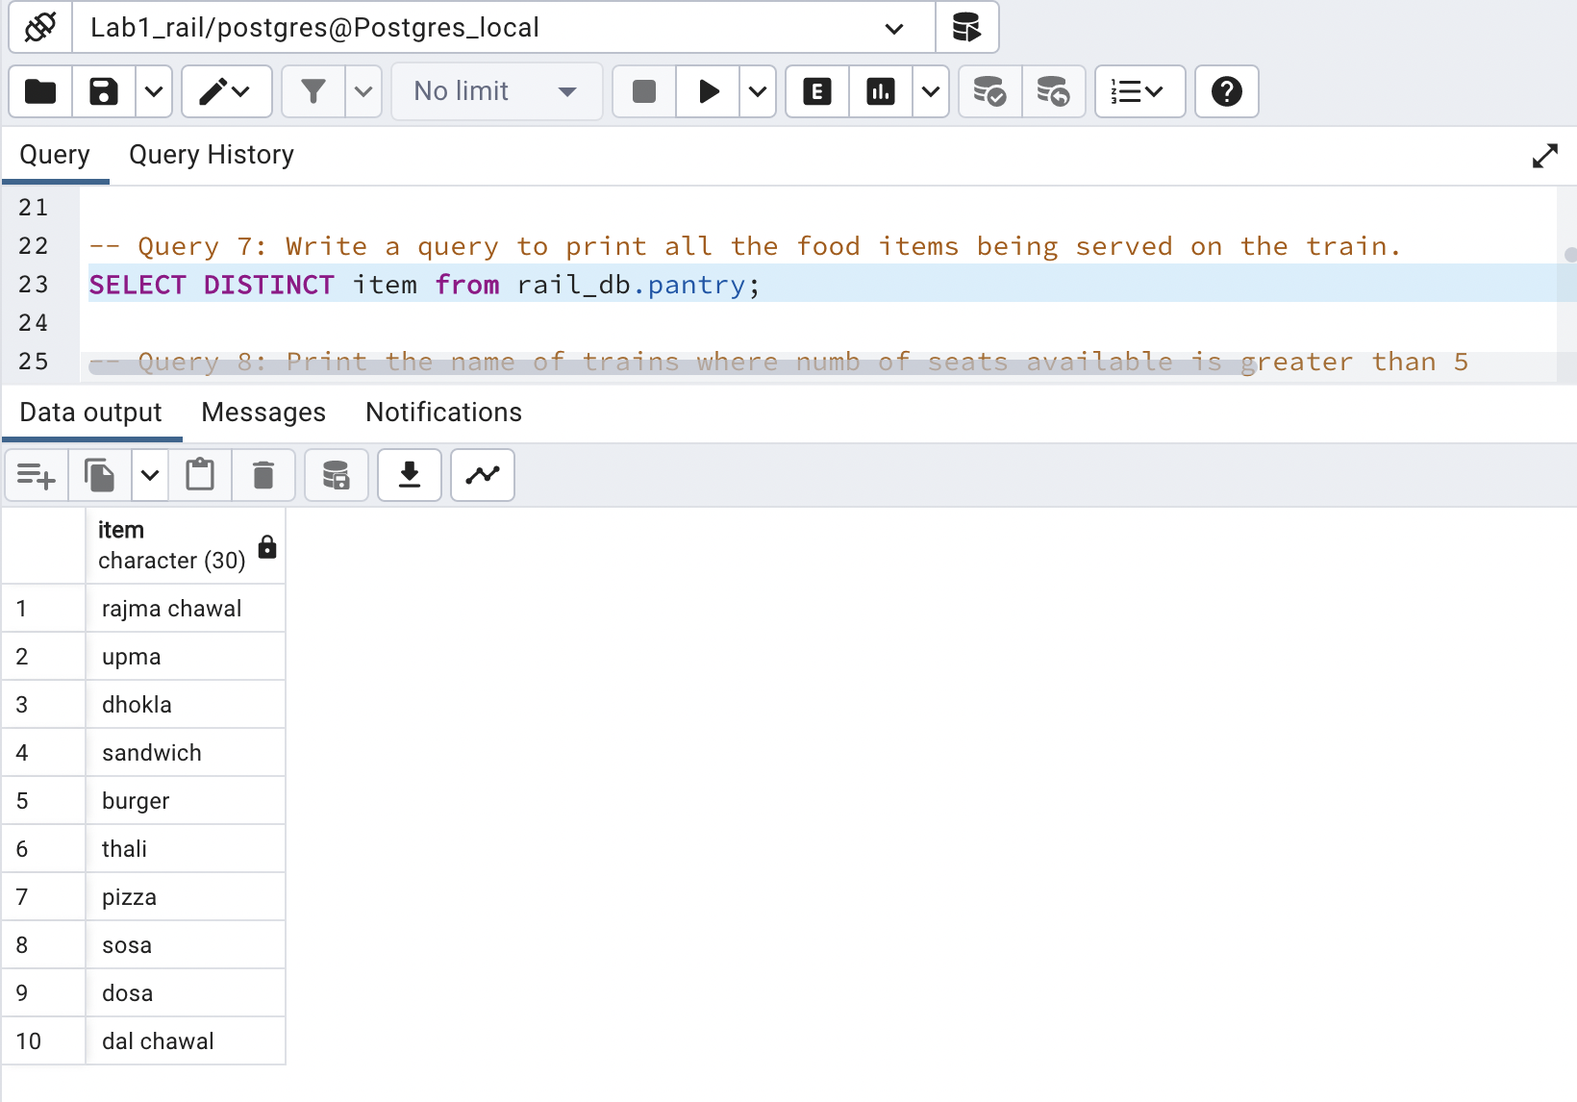

No of rows = 10

**Query 8: Print the name of trains where numb of seats available is greater than 5.**

**Ans. :** SELECT train_name FROM rail_db.train

WHERE seats_available>5;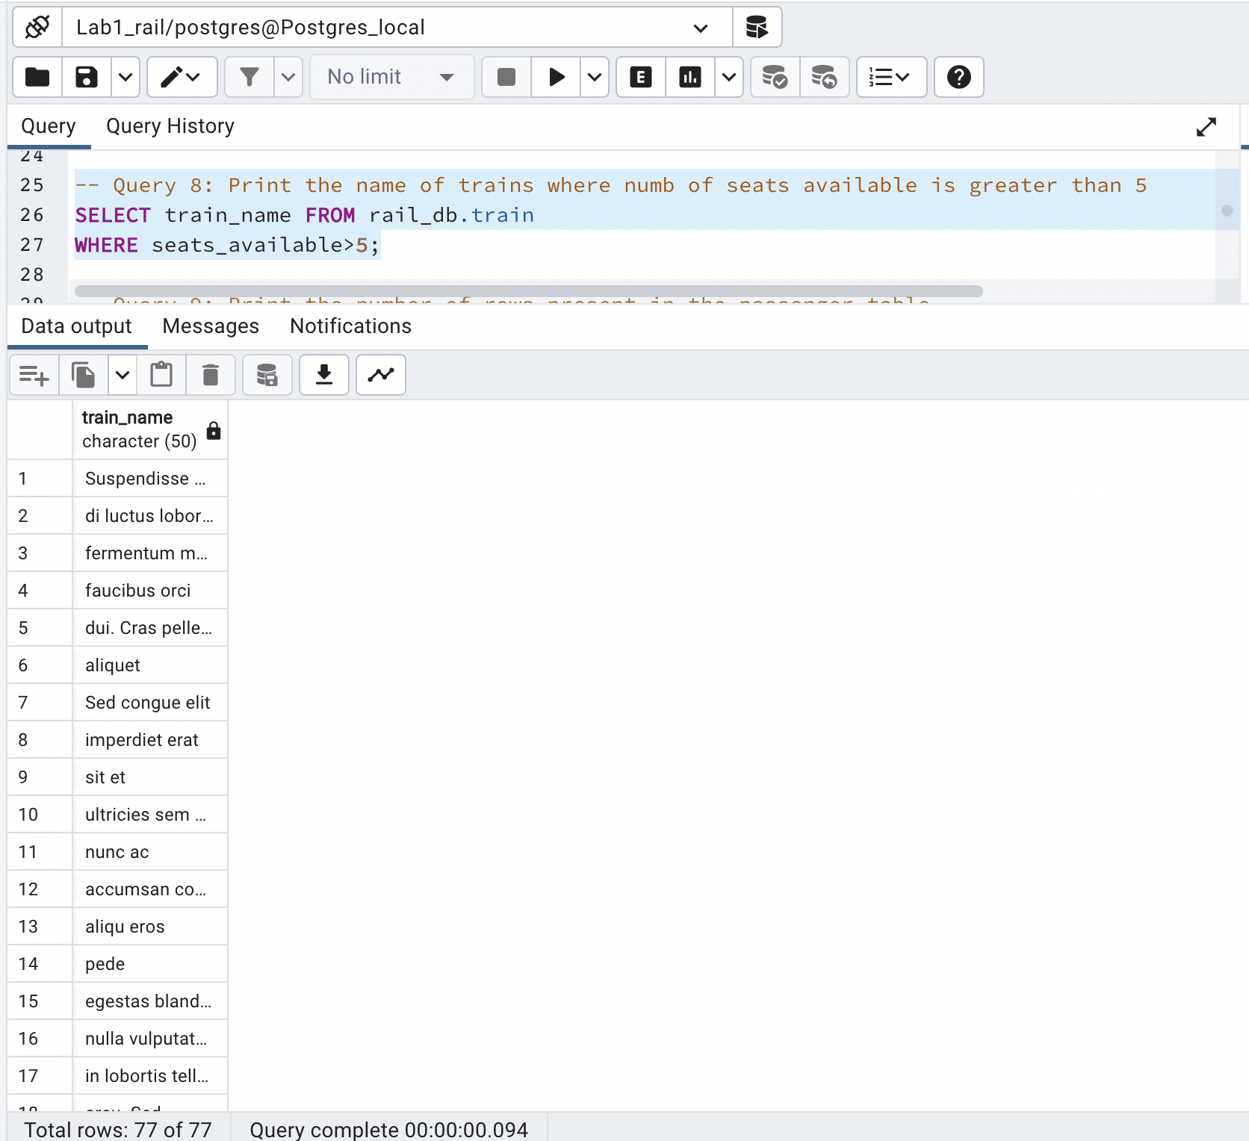

No of rows = 77

**Query 9: Print the number of rows present in the passenger table.**

**Ans. :** SELECT count(passenger_id) FROM rail_db.passengerdetails;

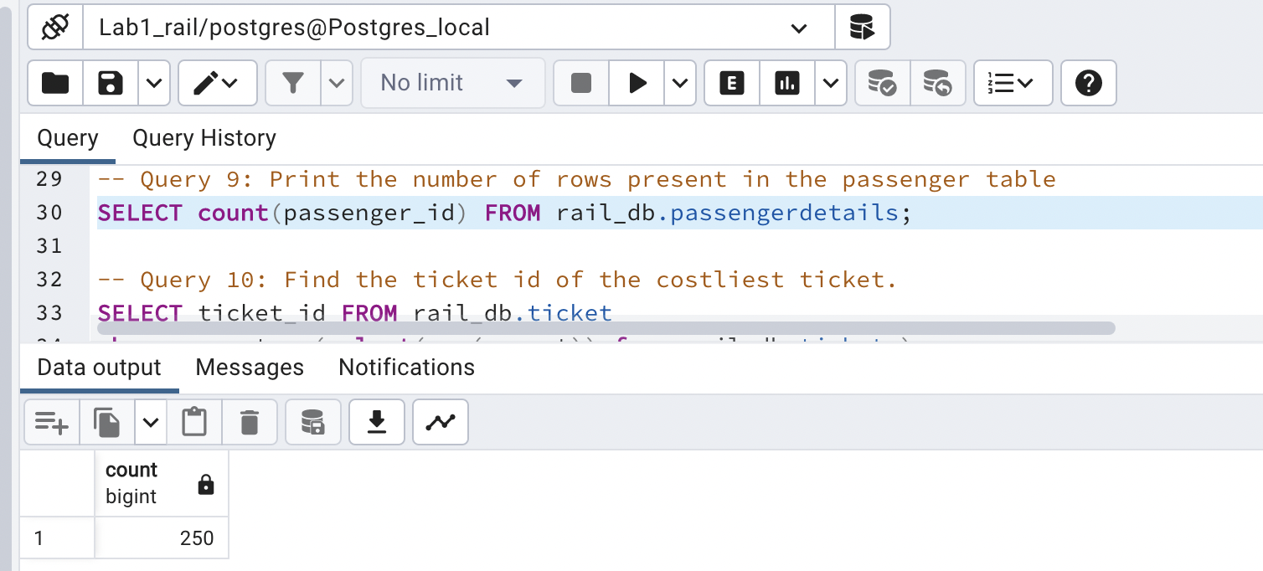

No of rows = 1

**Query 10: Find the ticket id of the costliest ticket.**

**Ans. :** SELECT ticket_id FROM rail_db.ticket

where amount = (select(max(amount)) from rail_db.ticket );

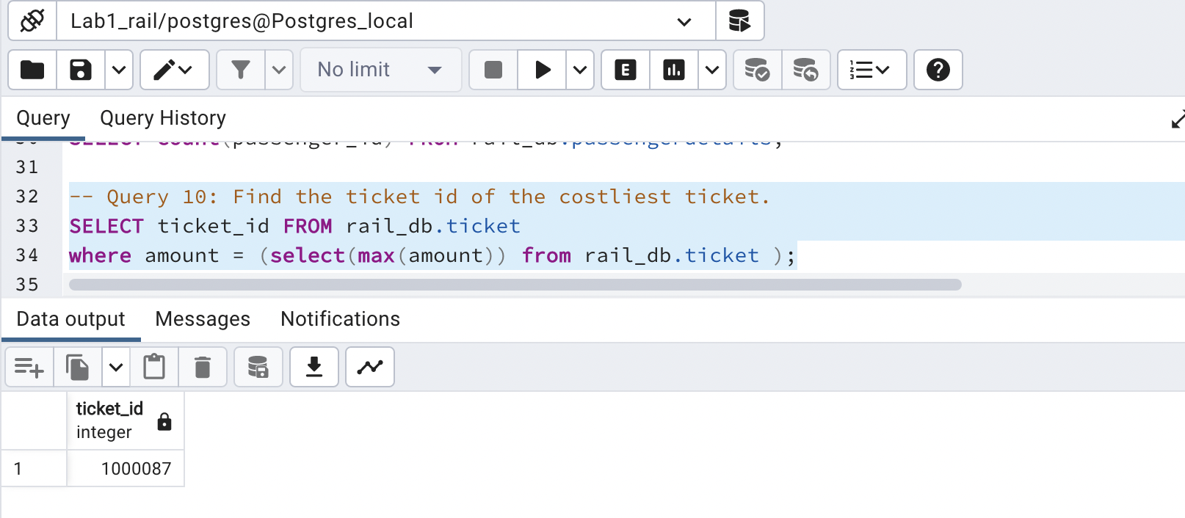

No of rows = 1

**Query 11: Show the second highest priced ticket_id.**

**Ans. :**

SELECT ticket_id FROM rail_db.ticket

ORDER BY amount DESC

LIMIT 1

OFFSET 1;

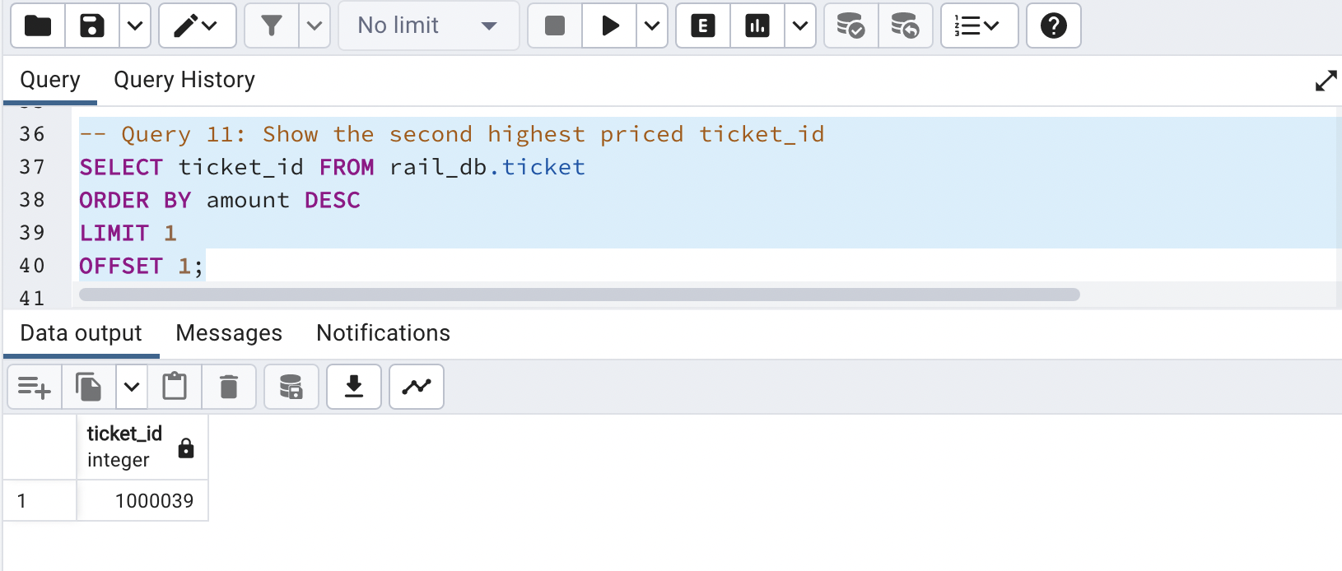

No of rows = 1

**Query 12: Print the name of passengers whose ticket is confirmed.**

**Ans. :** SELECT name FROM rail_db.passengerdetails

WHERE reservation_status = 'confirm';

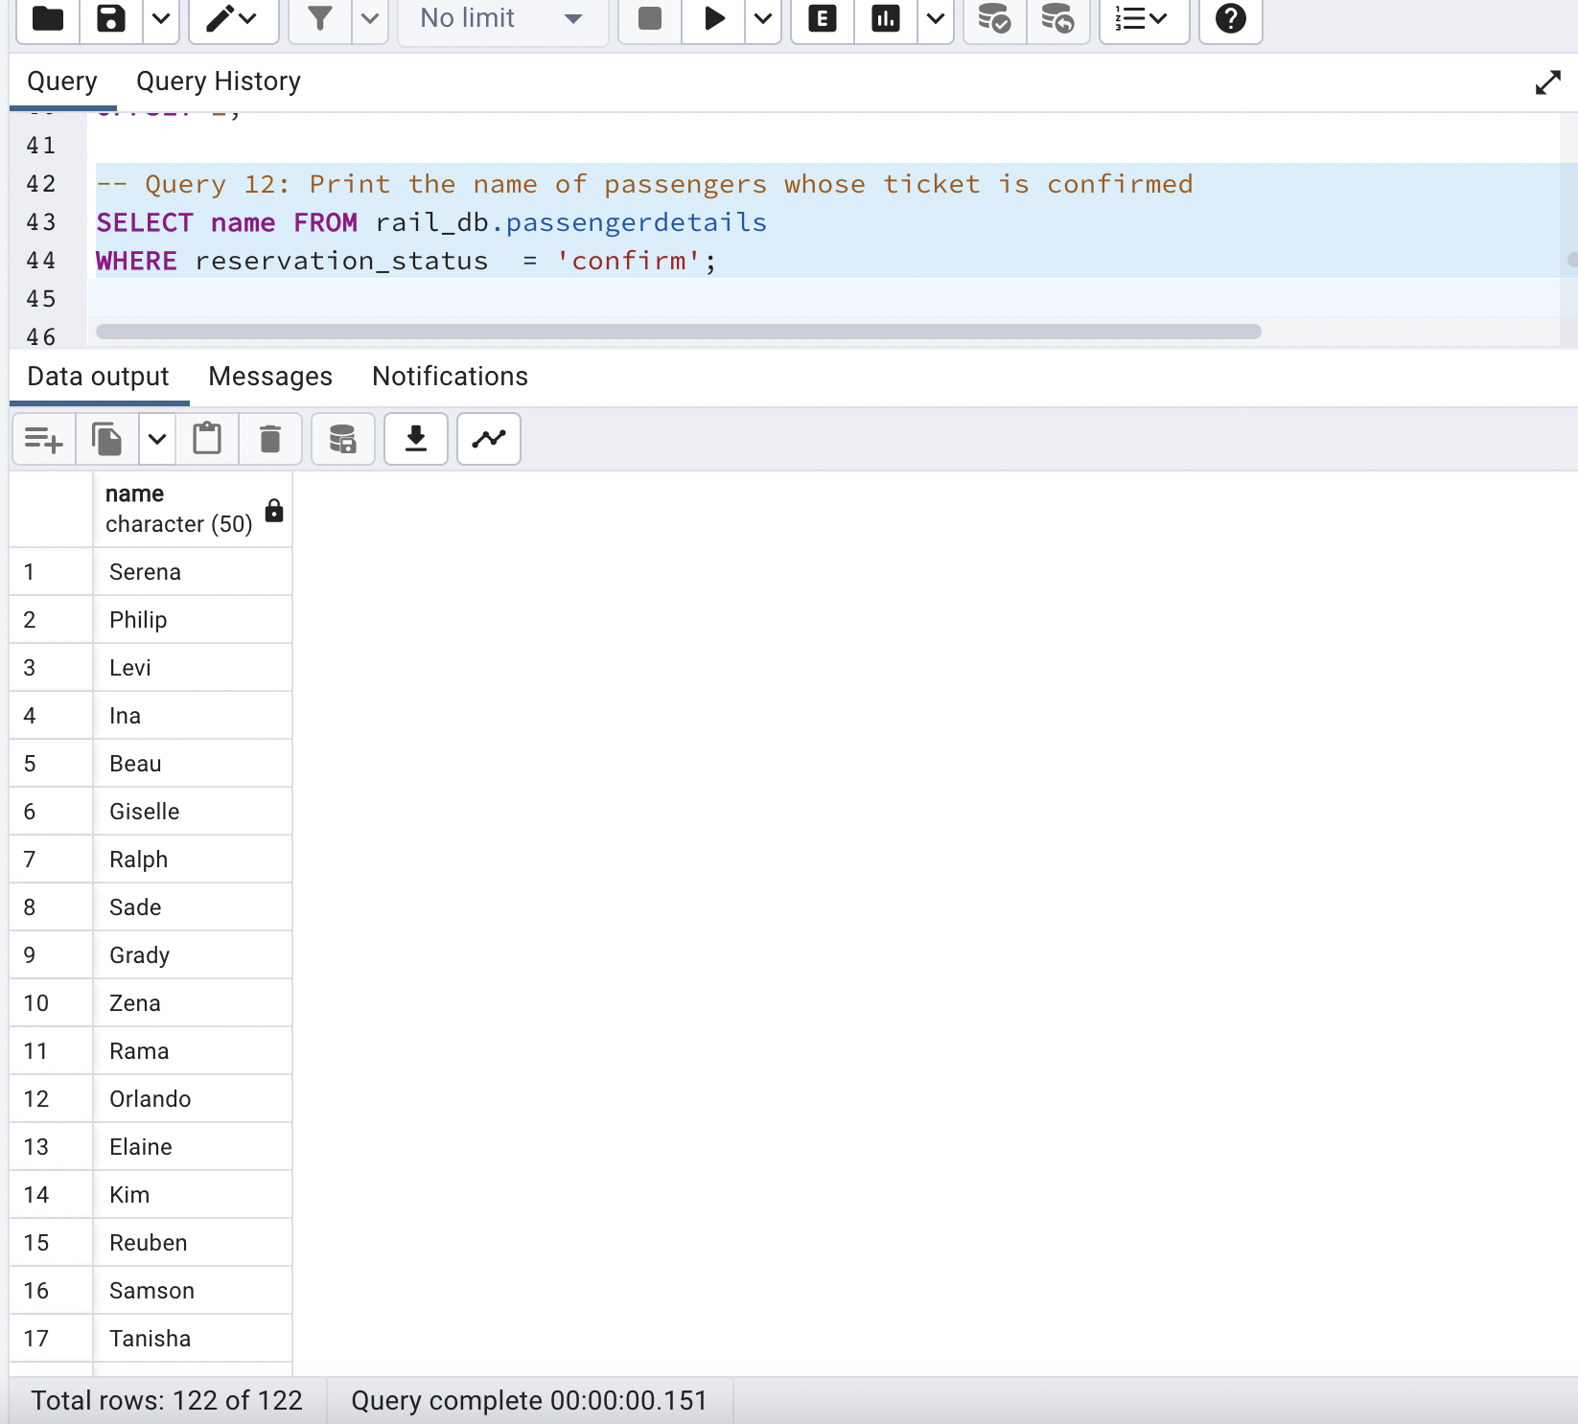

No of rows = 122

**Query 13: Print all the names of stations.**

**Ans. :** SELECT name FROM rail_db.station

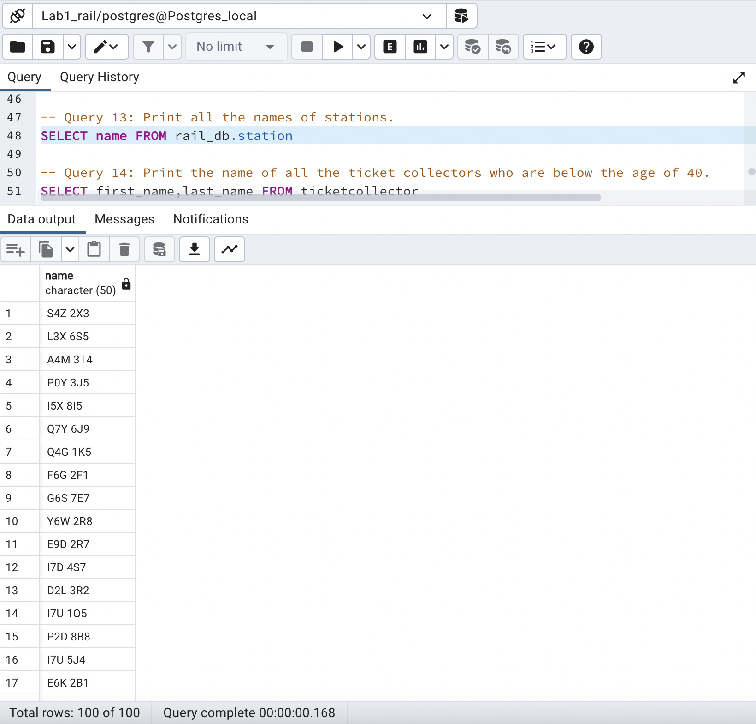

No of rows = 100

**Query 14: Print the name of all the ticket collectors who are below the age of 40.**

**Ans. :** SELECT first_name,last_name FROM rail_db.ticketcollector

WHERE age<40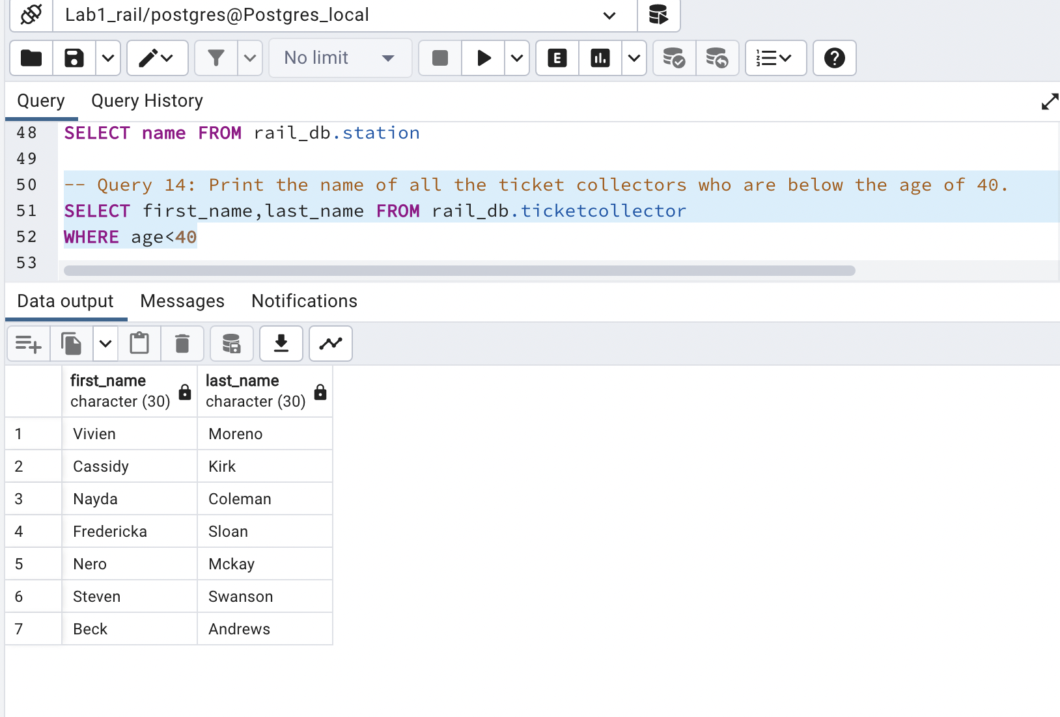

No of rows = 7

**Query 15: Write a query to print the number of foods that were available & their mode of payment was online.**

**Ans. :** SELECT * FROM rail_db.pantry

WHERE availability='Yes' and payment_mode='online'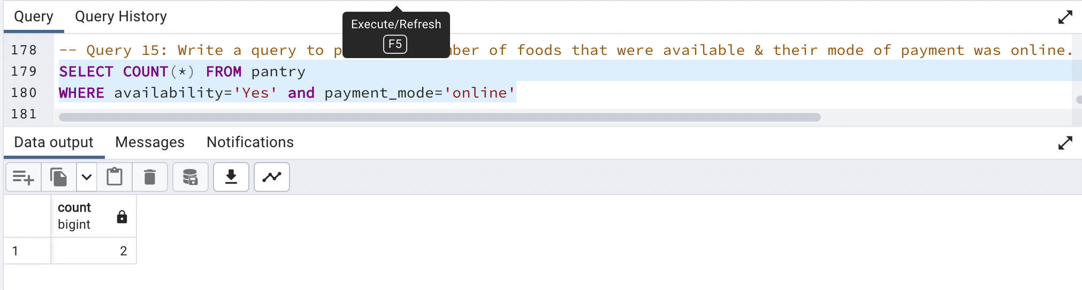

No of rows = 1